ORGANISATIONAL DEVELOPMENT AND CORPORATE SERVICES DIRECTORATE

1. Directorate Overview
  - Financial performance within Organisational Development and Corporate Services is projected as being on target for the year.

  - For the Directorate as a whole 9 (56%) performance measures are on target with 5 (31%) below target but within tolerance limits and 1 (6%) off target. One measure had no data at the time of writing. Risk management is currently reporting no red risks for these service areas and 13 amber risks.

2 Directorate Financial Performance

2.1 The Directorate is currently estimated to have a projected outturn position of £14.828 million, which is the same as the latest budget.

2.2 However outside of service budgets themselves there are other matters worthy of note as follows.

Treasury Management

2.3 Base rate remains at 0.5%. Total investments at the end of the quarter were £60.6m with £18.6m of this being held in Money Market Funds. There were no significant changes to the investment portfolio during the quarter. The average rate of return is fractionally lower than the previous month which is mainly due to the reinvestment of funds into the Bank of Scotland but at a lower interest rate than before due to a general decline in market rates.

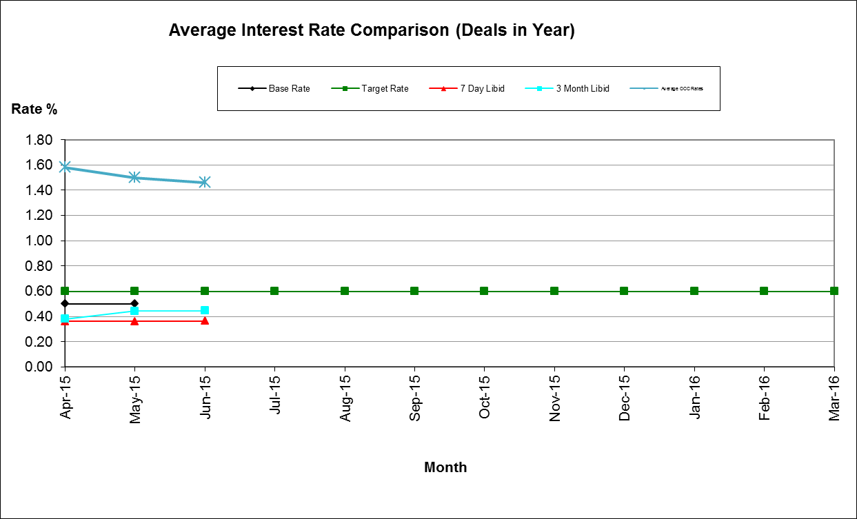

Housing Benefit Overpayments

2.4 The overall value of HB Overpayments outstanding has dropped by £0.447 million since 1st April primarily due to debt being written off against the bad debt provision (£4.136 million as at 31st March 2015).

2.5 However, the value of overpayments outstanding at the end of June 2015 was £5,625k, an 11% increase on June 2014. Officers are currently reviewing all outstanding arrears to identify any debt that is not collectible with a view to writing this off.

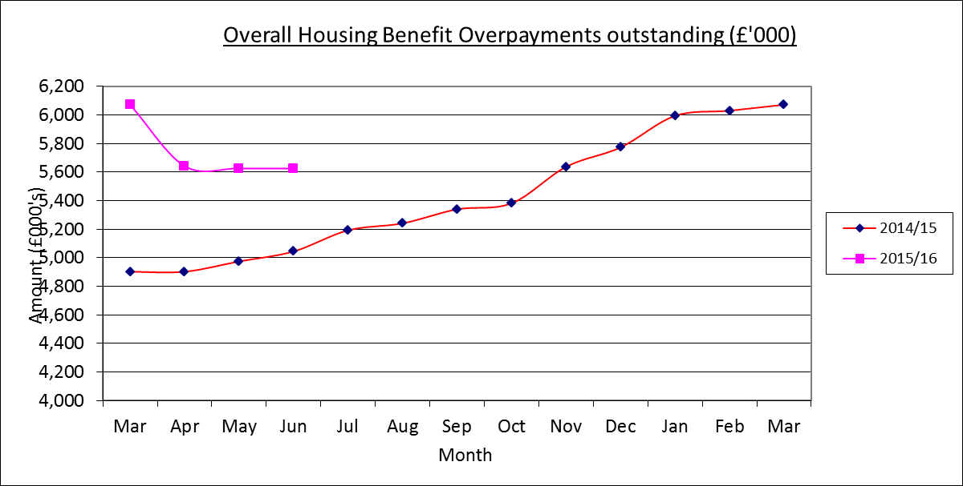

Business Rates Collection

2.6 Arrears of non-domestic rates carried forward on April 1st 2015 were £2.469 million which is £0.854 million (25.7%) down on the corresponding figure 12 months earlier.

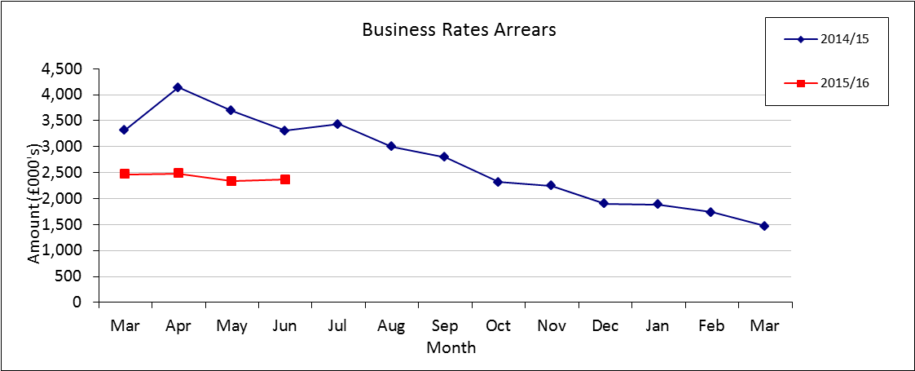

2.7 Over the first quarter of 2015/16 net arrears fell by £0.102 million with the end of June figure being £2.367 million. This is 28.5% less than the figure 12 months ago.

2.8 The 2015/16 collection rate was 31.84% at the end of the quarter which is better than the profiled target of 30% and an improvement on the previous year's equivalent of 31.04%. June in particular was a good month with 9.49% of the year's collectable debit being recovered within the month. The collection rate for 2014/15 has moved on from 98.80% at the end of 2014/15 to 98.93% three months later.

Council Tax Arrears Collection

2.9 Arrears of Council Tax (i.e. payments due for years 1993-94 up to 2014/15) carried forward on 1st April 2015 were £5.392 million, a 21.4% decrease on the corresponding figure 12 months earlier. That total included outstanding Court Costs of £0.378 million.

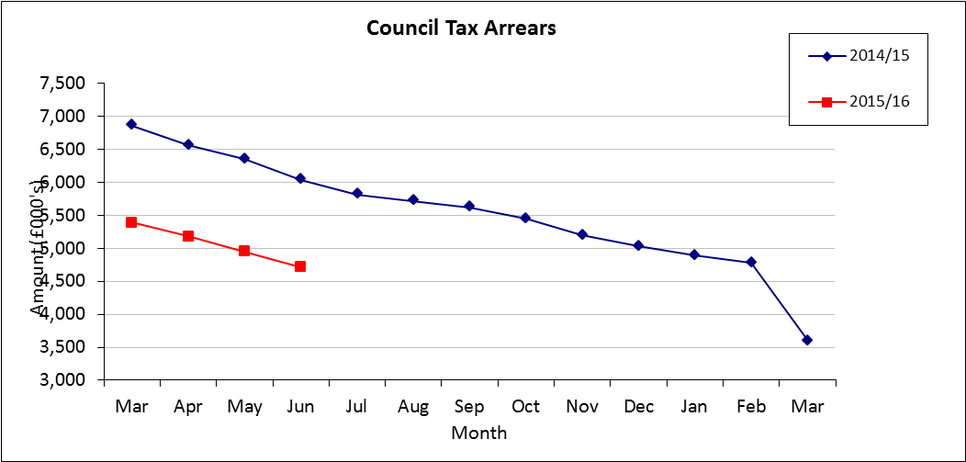

2.10 Over the first quarter of 2015/16 arrears fell by £0.674 million to £4.718 million (including Court Costs of £0.512 million), a 21.8% improvement on the level of arrears 12 months before. Payments (net of refunds) received in the first quarter totalled £0.687 million and write offs of £0.058 million have been processed. Court Costs totalling £0.046 million have been raised in respect of previous years' Council Tax and debit adjustments (cancelling of discounts and exemptions, and banding increases) amounted to £0.025 million.

2.11 The collection rate for 2015/16 at the end of the quarter was 31.05%. The corresponding figure 12 months previously was 30.97%. The collection of arrears has exceeded the end of quarter profiled target of 30% by £0.780 million. The collection rate for 2014/15 has moved on from 97.67% at the end of 2014/15 to 98.10% three months later.

3. Directorate Performance - Exceptions

Organisational Development
3.1 Days lost to sickness to June 2015 was at 1.52 days across the Council, just above the target of 1.50 days.

3.2 Percentage of employees with a disability – At June 2015, 8.72% of staff were identified as having a disability, against a target of 10%. Staff numbers have remained stable at around/ close to this figure for a number of months. The Council recently hosted a series of workshops with external partners such as Restore based on workplace resilience and will be piloting disability awareness sessions for customer services in August. HR will be exploring ways of developing a workplace pilot for work experience for people with disabilities

3.3 Percentage of black and ethnic minority employees – At June 2015, 7.4% of staff were from target communities, compared to a target of 9.0%. Numbers remain relatively stable. HR are planning two BME focus groups/ external community engagement workshops in the autumn to sell the benefits of working for the council and to pick up views on any perceived barriers to applying/ working here. An internally focused action plan will be drawn up to progress improvements.

Financial Services
3.4 Percentage of rent collected – 91.77% for June 2015 was marginally below the year to date target of 92.50%.

3.5 Percentage of invoices paid on time – Currently 85.20% of invoices are being paid on time compared to the target of 98%. Financial Services staff will be working with service managers to deliver improvements in this area for future months.

3.6 Time to process new benefits claims – As at the end of June, 1,097 new applications for Housing benefit and Council Tax support had been processed in the current financial year. Average processing time was 15.66 days. This is over the target of 14 days and the situation will be closely monitored over the coming months.

4. Risk Performance- Exceptions
4.1 There are no red risks in the Directorate but there are 9 amber risks detailed below. All these risks are currently being managed as part of day to day business activity and are not currently expected to rise to a level of red risk.

Business Improvement
4.2 Four amber risks have been identified in this area relating to the volume of ICT projects, the lack of resources to ensure resilience in the contact centre, not achieving savings targets and potential data protection breaches.

Law and Governance
4.3 The amber risks identified in this area relate to the resilience of the service, ensuring secure permanent safe keeping of city archives, ensuring the electoral register is accurate and complete, ICT support is sufficient and ensuring public safety at St Giles Fair.

